We Are The Walking Dead, No, Really, We Are.
An essay by Kate Fletcher. 

Revisiting “The Walking Dead” offers more than just a refresher on the series’ events; it provides an opportunity to delve into its complex narrative and thematic layers. This critically acclaimed show masterfully blends the stark realities of a post-apocalyptic world with deep, character-driven storytelling. Each episode is crafted to challenge the viewer’s understanding of morality, survival, and human nature, making it a rich source of inspiration for developing a show that could parallel real-world crises or the daily struggles of personal life. The series is particularly compelling because it portrays how ordinary people react when stripped of societal norms and thrust into relentless, life-altering situations.
The emotional and ethical dilemmas faced by the characters in “The Walking Dead” resonate deeply with me, particularly in light of my family’s experiences. The relentless hunger of the walkers echoes the challenges posed by my brother Shields’ Prader-Willi syndrome, a condition characterized by an insatiable appetite.
This parallel extends beyond a mere narrative device, serving as a poignant metaphor for the daily realities of living with such a syndrome. The series’ focus on survival and the characters’ varied responses to their dire circumstances provide a lens through which to view our family’s resilience and adaptability in the face of chronic health challenges.
At its core, “The Walking Dead” is a meditation on morality under duress. The series excels in exploring how extreme conditions can alter one’s ethical landscape, pushing characters to the brink of their moral limits. Early episodes introduce us to a world where every decision can mean the difference between life and death, forcing characters to weigh their survival against their humanity. This theme is vividly illustrated through their interactions and the choices they make, which often involve sacrificing long-held beliefs for the sake of protecting themselves and their loved ones. This narrative exploration serves as a powerful allegory for the ethical quandaries one might face in any severe crisis, whether personal or global.
“The Walking Dead” confronts the concept of death in a manner few other series dare to explore. Unlike typical portrayals that often avoid the harshness of death, this series embeds the inevitability and frequency of death into its very fabric, compelling characters and viewers alike to face mortality head-on. This relentless confrontation with death challenges the characters to adapt or succumb, pushing them into profound existential reflections. It also mirrors societal attitudes towards death, where it is often sanitized or hidden away, and highlights the necessity of confronting such realities directly.
Through its unflinching depiction of death and survival, “The Walking Dead” encourages a deeper understanding of life’s fragility and the human capacity for resilience in the face of relentless adversity.
This introduction sets the stage for a deeper exploration of specific characters and themes within “The Walking Dead,” illustrating how the show’s narrative complexity can be paralleled to real-life challenges and ethical dilemmas. Each element mentioned here—character development, moral complexity, and the existential confrontation with death—will be expanded upon to provide a comprehensive analysis of the series and its relevance to personal and universal human experiences.
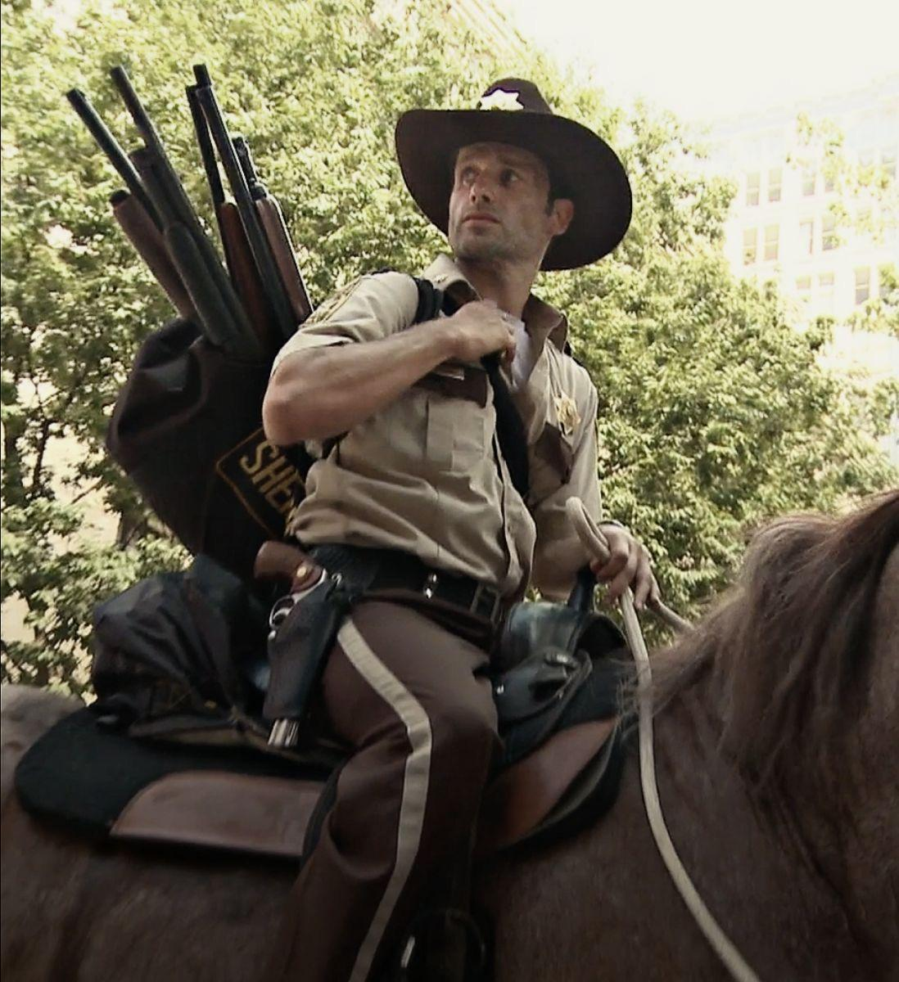
Rick Grimes' journey from a principled sheriff to a hardened survivor encapsulates the transformational arc central to "The Walking Dead." Initially embodying the law and order of the old world, Rick's character quickly becomes a symbol of the struggle between maintaining societal norms and adapting to the new lawless reality. His evolution is marked by an increasingly pragmatic approach to leadership, where moral decisions are not just about right and wrong but about what will keep the group safe in a world where the rules have changed drastically.
Rick's role as a leader is laden with burdens that test his ethical boundaries and personal resilience. He finds himself making decisions that weigh heavily on his soul, understanding that each choice could mean life or death for his group. This aspect of his character highlights the intense pressure faced by leaders in crisis situations—mirroring the decisions that must be made by political and military leaders in real-world conflicts. Rick's leadership style evolves from a focus on democratic ideals to a more authoritarian approach when necessary, illustrating the complexities and compromises inherent in leadership during times of extreme turmoil.
Throughout the series, Rick encounters numerous moral dilemmas that challenge his foundational beliefs and the ideals of the society he once enforced as a sheriff. His confrontations with characters like Shane, the Governor, and Negan force Rick to navigate a spectrum of ethical challenges, from dealing with betrayal within his group to facing off against brutal leaders who threaten their survival. These conflicts are not just physical but deeply philosophical, forcing Rick and the viewer to reconsider what constitutes moral action in a drastically altered world.
Rick's leadership significantly influences the group's dynamics, fostering a sense of loyalty and often dictating the group's moral compass. His decisions impact how the group views survival, community, and justice, shaping their actions and interactions. As he grapples with his responsibilities and the consequences of his choices, Rick's character study offers viewers insights into the psychological and emotional toll of leadership under constant threat. His interactions often reflect broader themes of trust, sacrifice, and the need for community in times of isolation and danger.
Rick Grimes' character arc is a profound narrative thread in "The Walking Dead," offering a detailed exploration of leadership and morality in extreme conditions. His transformation from a law-abiding officer to a leader in a post-apocalyptic world provides a compelling lens through which to examine the nature of authority and ethical decision-making when the familiar order has collapsed. As we delve further into the series, we can continue to draw parallels between Rick's experiences and broader human experiences, particularly in how individuals and leaders manage crisis and moral complexity.
In many ways, my mother mirrors the character of Rick Grimes from "The Walking Dead." Like Rick, who awakens in a post-apocalyptic world from a hospital bed, my mother found herself thrust into a harsh new reality when she learned of my brother Shields' diagnosis with Prader-Willi syndrome.
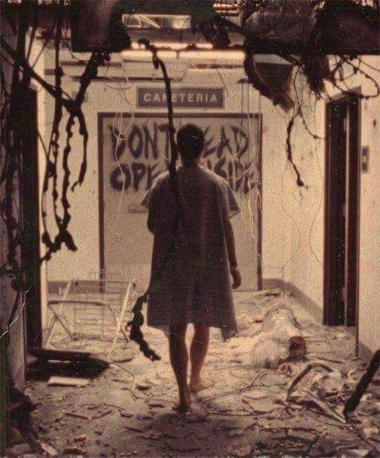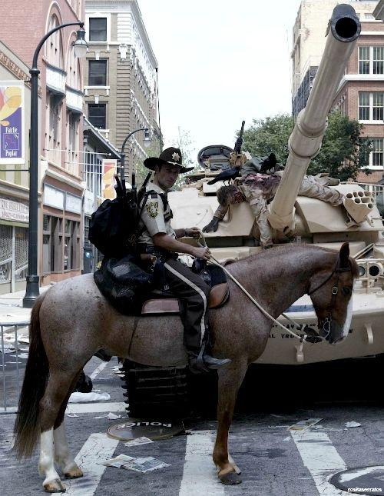
Just as Rick awoke to find the world transformed by a zombie apocalypse, my mother awoke to a life where she would need to continually fight for the survival and well-being of her family. This battle, though less about physical survival, involves a constant struggle against the challenges posed by the syndrome, advocating for Shields, and ensuring he has the quality of life he deserves.
Much like Rick Grimes, my mother's leadership is defined by resilience, sacrifice, and a profound sense of duty to her family. She navigates the healthcare systems, educational needs, and daily care with the same determination and protective instincts Rick shows for his group. Her decisions, often tough and fraught with emotional weight, reflect a leader's burden in maintaining the well-being of her family against seemingly insurmountable odds. Her role as the family's cornerstone showcases the real-world application of leadership qualities often dramatized in shows like "The Walking Dead."
In "The Walking Dead," the characters of Rick Grimes and Hershel Greene dramatically encapsulate the dual aspects of hope and despair that are often found within the same individual or in closely connected individuals facing the same existential crises. Their relationship serves as a powerful metaphor for the internal and external conflicts that arise in extreme circumstances, illustrating how two different approaches to the same problem can reflect broader personal and philosophical struggles.
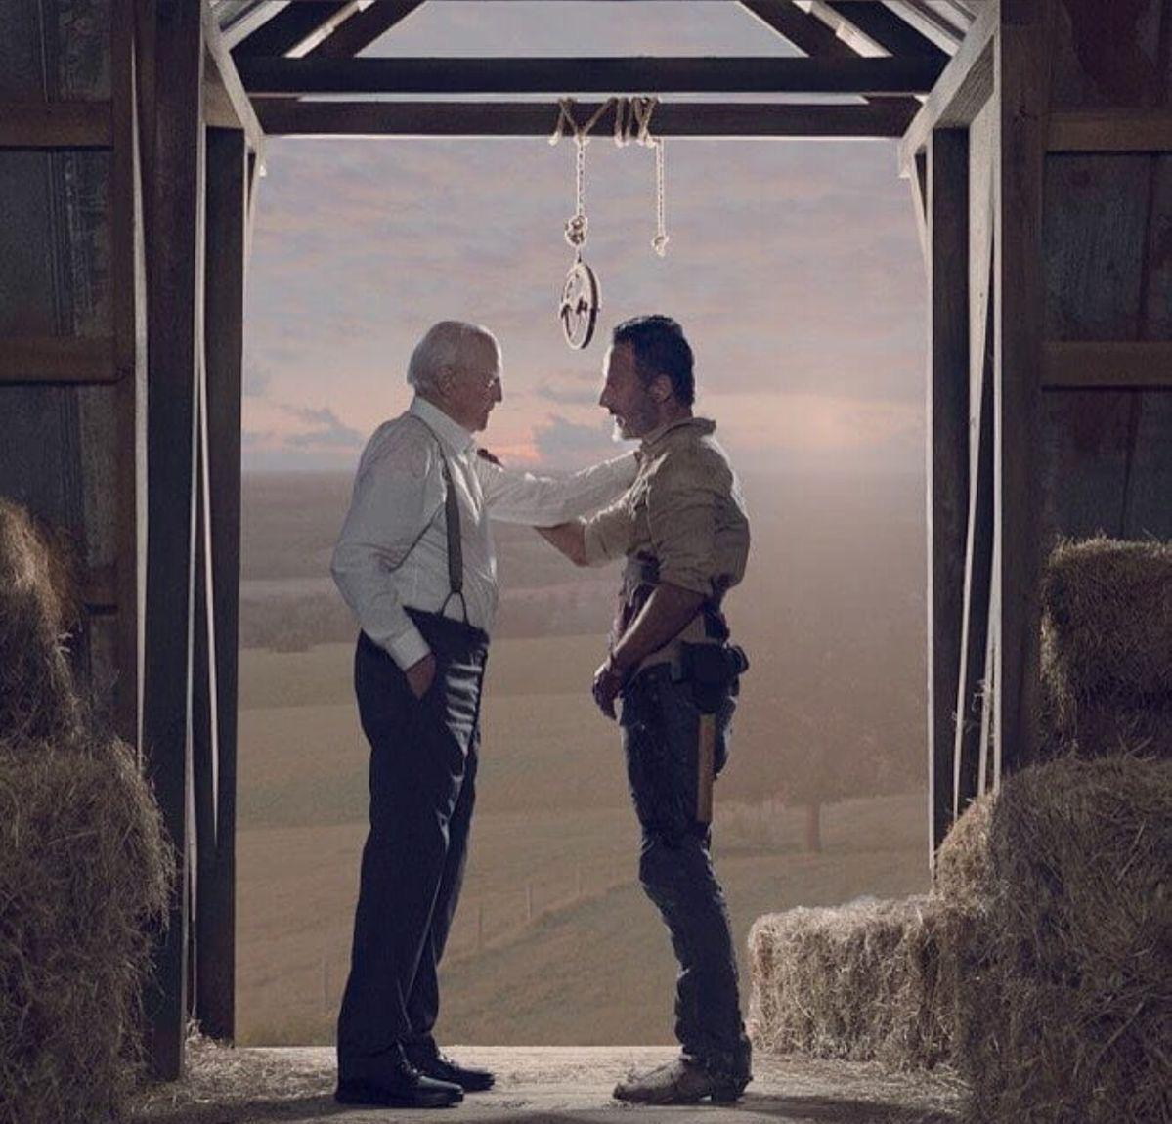
I see a poignant parallel between Rick and Hershel's dynamic and the relationship between my mother and her own parents, highlighting the generational differences in coping with crises and maintaining hope.
Rick, embodying hope and the relentless drive to protect his family and rebuild some semblance of society, contrasts sharply with Hershel's initial despair and resignation to the bleak new reality. This dichotomy reflects not only the conflict between hope and despair but also the varying responses to traumatic change one can observe within a family or community.
Like my mother, Rick holds onto hope and fights tirelessly for a better future, whereas Hershel, similar to my grandparents, embodies a more resigned perspective, burdened by the weight of his experiences and the losses he has endured.
Hershel's journey in the series, from a man in denial about the nature of the walkers to someone who eventually finds a new purpose in supporting Rick's vision, mirrors the transformative and sometimes tragic paths that many individuals undergo in their lifetime.
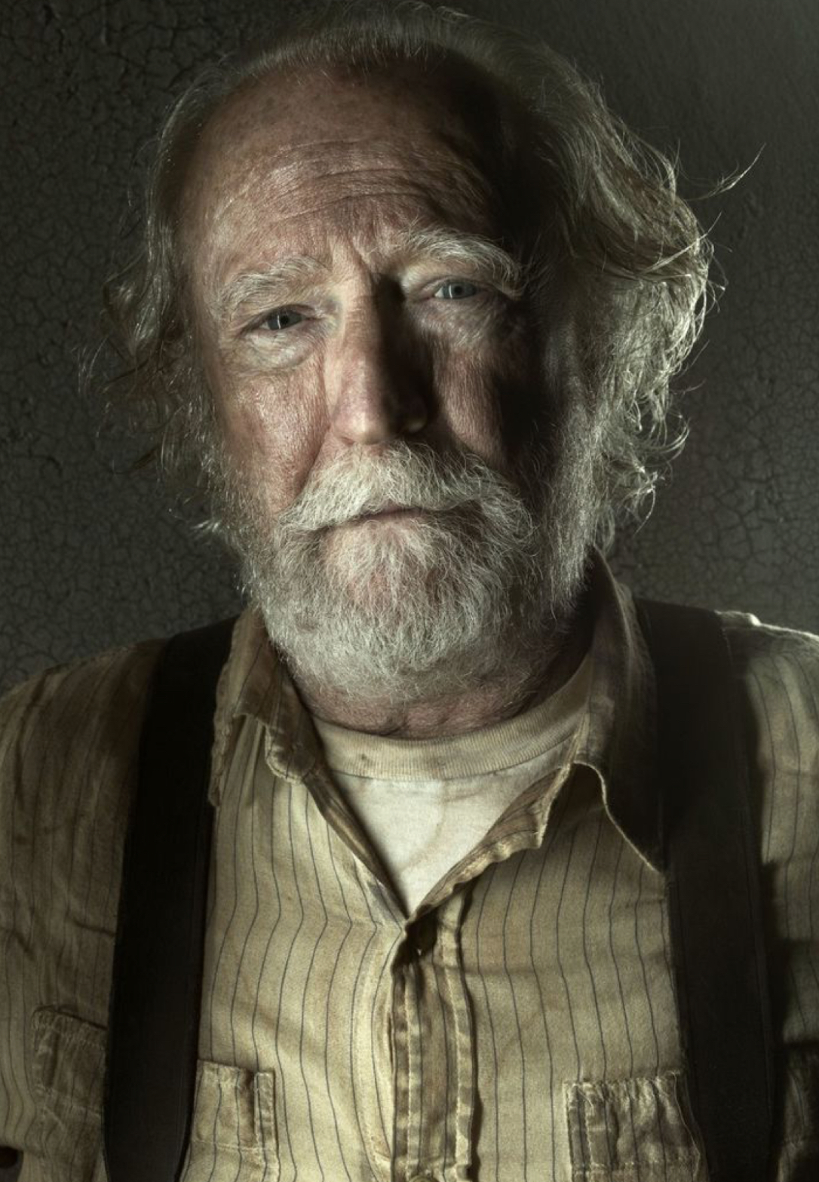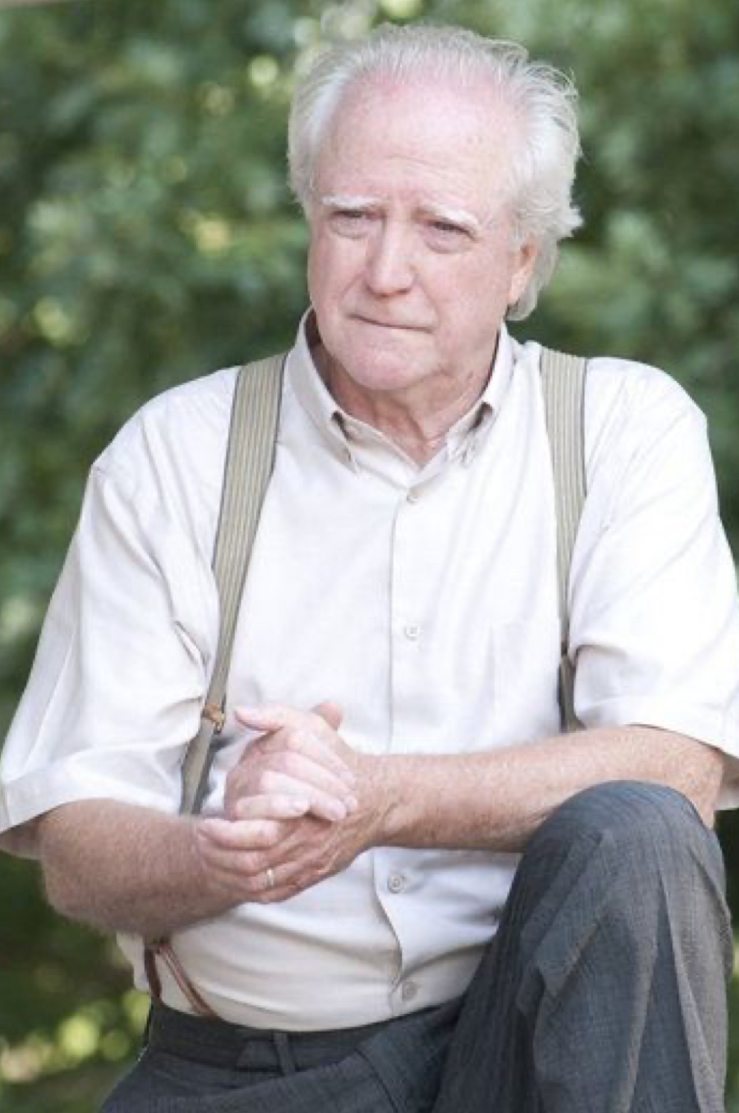
Hershel Greene stands as a beacon of hope and moral fortitude in "The Walking Dead." Initially a veterinarian who clings to the belief that the walkers are simply sick and can be cured, Hershel’s perspective evolves as the harsh realities of the new world become undeniable.
Tragically, Hershel's eventual death at the hands of the Governor—a literal loss of his head—symbolizes the ultimate price of his evolved beliefs and his commitment to a hopeful path.
This event has a personal resonance for me, reminding me of my grandmother’s struggles with early-onset dementia due to medical issues. Though not as dramatic as Hershel's fate, her cognitive decline was a profound loss, marking the end of her ability to engage with the world as she once did.
The comparison between Hershel and my grandparents extends beyond their immediate responses to crises. It also touches on the physical and psychological legacies that are passed down through generations.
Just as Hershel's physical struggles and eventual fate reflect the vulnerabilities that come with age and past decisions, so too do my grandparents' conditions and their consequences reflect the broader theme of inheritance—both genetic and emotional—that runs through both "The Walking Dead" and our lives. This inheritance influences how each generation responds to their circumstances and shapes their outlook on life and survival.
The Baby Boomer generation, exemplified by my grandparents, often struggles to see the world for what it is today.
If they don’t adapt to the current realities, they risk losing themselves, much like Hershel lost his head. This generational gap underscores a broader societal challenge where older generations must reconcile their past beliefs with the present's stark realities.
In this way, "The Walking Dead" offers a profound exploration of the human condition, examining how individuals and families navigate the spectrum between hope and despair. The series provides a narrative framework that helps to understand and articulate the complex dynamics within my own family, offering insights into the resilience required to face both the walkers of the fictional world and the equally daunting challenges of the real world.
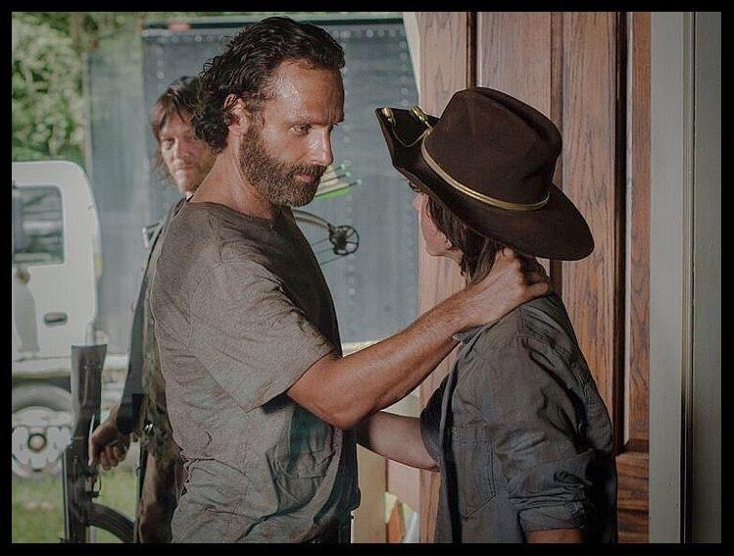
In this familial setting marked by challenges, I find my role akin to that of Judith or Carl Grimes, children who grow up in the chaotic environment of the post-apocalyptic world yet learn the importance of mercy and compassion. Like Carl, who evolves to understand and advocate for the philosophy that "all life is precious," I have learned from the environment of care and resilience around me. Carl's journey, particularly his interactions with characters like Jesus, who teaches him the value of life and peace, mirrors my own growth in a family where caring for someone with special needs redefines the meaning of normalcy and justice.
Just as Carl influences Rick with his more merciful views, leading to pivotal decisions that often save lives and maintain humanity within the group, I see myself playing a similar role in my family. My experiences have taught me the importance of empathy, patience, and the broader impacts of kindness. These lessons drive me to influence my family towards decisions that consider long-term wellness over immediate survival. In advocating for approaches filled with compassion and understanding, I help steer our family dynamics towards nurturing and supportive, much like Carl's impact on his father and their group's larger decisions.
The parallels between "The Walking Dead" and our family dynamics not only highlight the universal themes of the series but also offer a framework through which we can view our own lives. The characters of Rick, Carl, and Judith Grimes provide a lens to examine the roles we play within our families, especially when faced with extraordinary circumstances. This reflection deepens our appreciation for the narratives we follow in fiction, recognizing their power to mirror, influence, and inspire our real-world actions and choices.
In a poignant and deeply reflective letter, Carl Grimes expresses his vision for the future and his hope for a return to peace and normalcy, despite the harsh realities of their world. His words encapsulate a desire for not just survival, but a meaningful life beyond the constant struggle. Here is the full text of Carl's letter to his father, Rick:
“I remember my 8th birthday at the KCC with the giant cake and Aunt Evie showing up on leave surprising all of us.
I remember mom.
I remember Codger. I remember school and going to the movies and Friday night pizza and cartoons and grandma and grandpa and church.
Those summer barbecues and the kiddie pool you got me — could have used that at the prison.
You told me about the walks we’d take when I was three … you holding my hand around the neighborhood all the way to Ross’ farm.
I didn’t know that I remembered them, but I do because I see the sun and the corn and that cow that walked up to the fence and looked me in the eye.
And you told me about all that stuff but it isn’t just that stuff. It’s how I felt.
Holding your hand,
I felt happy and special and I felt safe.
I thought growing up was about getting a job and maybe a family, being an adult.
But growing up is making yourself and the people you love safe, as safe as you can because things happen.
They happened before.
You were shot before things went bad, but I kind of felt like things went bad because you were shot.
I want to make you feel safe, dad. I want you to feel just like I felt when you held my hand
. Just to feel that way for five minutes, I’d give anything to make you feel that way now.
I wanted to kill Negan. I wish I did, maybe it would have been done.
I don’t think it’s done now. You went out there again, but I don’t think they surrendered.
I don’t think they will surrender.
There were workers there, dad. They’re just regular people — old people, young people, families.
You don’t want them to die, dad.
We’re so close to starting everything over and we have friends now.
That bigger world Jesus talked about, the Kingdom, the Hilltop, there’s got to be more places, more people out there, a chance for everything to change and keep changing…
…everyone gives everyone the opportunity to have a life, a real life.
So if they won’t end it, you have to.
You have to give them a way out. You have to find peace with Negan.
Find a way forward somehow.
We don’t have to forget what happened,
but you can make it so that it won’t happen again,
that nobody has to live this way, that every life is worth something.
Start everything over.
Show everyone that they can be safe again without killing….They can feel safe again.
That it can go back to being birthdays, and school, and jobs, and even
Friday night pizza somehow, and walks with a dad and a three-year-old holding hands.
Make that come back, dad.
And go on those walks with Judith.
She’ll remember them.
I love you,
Carl.
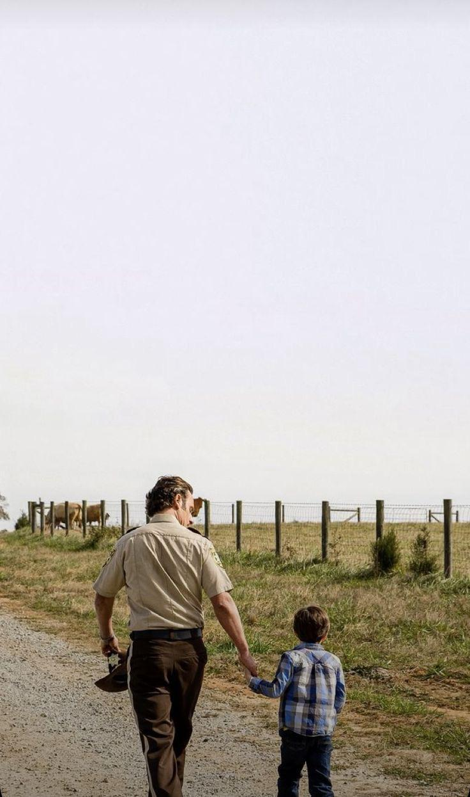

Carl's letter is not only a heartfelt plea for peace and a return to normalcy but also a powerful reminder of the human capacity for hope and the desire for a better future. It underscores the series' recurring theme that even in the darkest times, the aspiration for a peaceful and meaningful life remains strong. Carl’s vision extends beyond mere survival; it is a call to rediscover and cherish the simple joys of life, highlighting the potential for renewal and change even in a world ravaged by conflict.
"The Walking Dead" experienced a significant shift in viewer dynamics and narrative focus following the departure of key characters like Rick and Carl Grimes. Their exits marked a pivotal moment in the series, as both characters had been central to its thematic exploration of humanity, ethics, and survival.
Rick, in particular, embodied the moral compass of the show, grappling with leadership and the burdens of decision-making in a way that resonated deeply with the audience. Carl's growth from a child into a young adult with his own complex views on morality and hope represented the future generation's potential to overcome and adapt to the new world. Their loss left a void that significantly altered the show's connection with its viewers, suggesting a departure from exploring deep humanistic themes towards more survival-centric narratives.
The diminishing focus on humanity within "The Walking Dead" can be seen as a mirror to contemporary societal shifts, where often, the complexities of human emotion and ethical dilemmas are overshadowed by the mechanisms of control and survival. The introduction of groups like the CRM (Civic Republic Military) represents this shift well. The CRM's portrayal as a powerful entity focused on control and order at any cost reflects a broader societal anxiety about loss of personal freedoms and autonomy in the face of governmental or institutional power. This narrative shift from personal morality tales to broader political dynamics may have contributed to the disengagement of viewers who were initially drawn to the series for its intense, character-driven stories about maintaining one's humanity in a world gone mad.
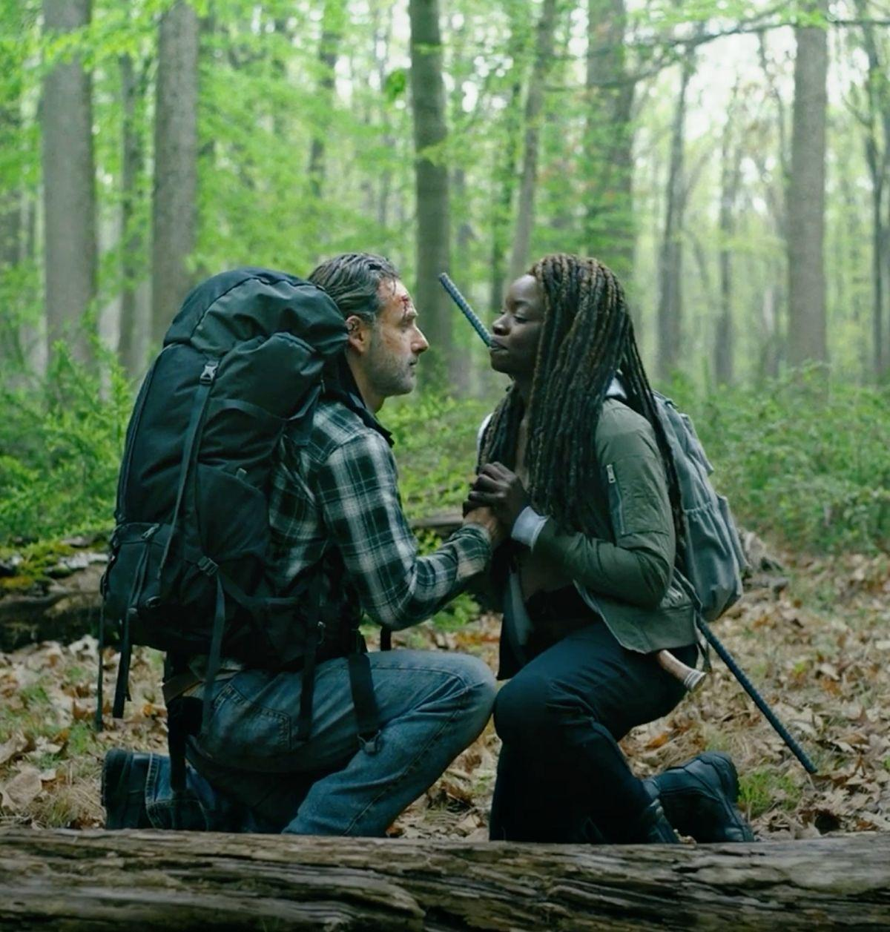
Rick and Michonne, in their roles as parents and protectors, continue to symbolize the struggle of every individual or family trying to protect their loved ones against overwhelming odds. This portrayal resonates strongly with an American audience that values individualism and the protection of personal and family rights against external threats. Their journey reflects a common narrative in American culture—the fierce determination to maintain family integrity and safety in a world that seems increasingly hostile and uncontrollable. By focusing on their efforts to safeguard their family, the series taps into a universal theme of parental and communal responsibility, albeit within the dramatic and hyperbolic context of a zombie apocalypse.
The shift in narrative focus away from the individual ethical struggles towards larger socio-political conflicts may explain the decline in viewer engagement. As the series moved away from the intimate, relatable struggles of characters like Rick and Carl, and towards broader themes of control and societal restructuring, it may have lost the crucial element that once made it so compelling: its heart. This change reflects not only a shift in storytelling focus but also may be indicative of a broader societal trend where the nuances of personal human experiences are subsumed under the weight of larger, more impersonal conflicts.
In conclusion, "The Walking Dead" serves as a complex reflection of contemporary societal dynamics and the challenges of maintaining humanity and ethical integrity in times of widespread crisis. The evolution of the series and its impact on viewers offer a rich case study for understanding how narrative shifts can reflect and influence public sentiment and cultural trends. As we examine the trajectory of the show and its characters, we gain insights into the interplay between personal values, societal pressures, and the universal quest for survival and protection in an uncertain world.
As we delve into the themes of survival and ethical decision-making within "The Walking Dead," it becomes evident that these concepts extend beyond the realm of fiction to shape our own reality. The choices we make in selecting our leaders and allocating resources have profound moral and ethical implications that resonate with the challenges faced by characters in the post-apocalyptic world.
In a world teetering on the brink of collapse, the decisions we make as individuals and as a society hold the key to our collective survival.
Our moral and ethical choices play a pivotal role in shaping the trajectory of our society, especially in times of crisis. Just as characters in "The Walking Dead" are forced to confront their ethical boundaries and make difficult decisions to ensure their survival, we too are tasked with selecting leaders who uphold values of integrity, compassion, and justice. The way in which leaders allocate resources and prioritize the well-being of their communities reflects not only their character but also the collective values of society as a whole.
In a world where the stakes are high and the consequences of poor leadership can be catastrophic, it is imperative that we hold our leaders to the highest moral standards.
The narrative complexity of "The Walking Dead" serves as a cautionary tale, reminding us of the dire consequences that can arise from ethical compromise and misguided decision-making. As we navigate the complexities of our current world, we must remain vigilant in our commitment to upholding moral and ethical principles in choosing our leaders and shaping the future of our society.
The parallels between the moral dilemmas faced by characters in "The Walking Dead" and the ethical challenges inherent in selecting our leaders highlight the interconnectedness of fictional narratives and real-world experiences. By examining the ethical landscapes depicted in the series, we gain valuable insights into the importance of integrity, empathy, and foresight in guiding our decisions and shaping the world in which we live. As we confront the uncertainties of our time, let us draw inspiration from the moral complexities of "The Walking Dead" to make informed and conscientious choices that will lead us towards a more just and sustainable future.

